My King Reigns
Psa. 110:1-2

Introduction:

1. Psa. 110 is frequently quoted in the N.T. It is one of the many O.T. passages that refer to the rulership of the Messiah.
2. Edward J. Young, in his O.T. Prophecy, identifies the “Authoritative” or “Regal Element” as one of five essential elements that appear in the concept of Messiahship as it is presented in the O.T.
3. As ruling authority the Messiah will completely subdue His enemies.
4. The following image illustrates Psa. 110. It is a statue of Ur-Ningirsu the Summarian ruler of Lagash circa 2120-2113 B.C. (before the time of Moses). Under his feet are the tributaries kneeling and bringing gifts to the king.

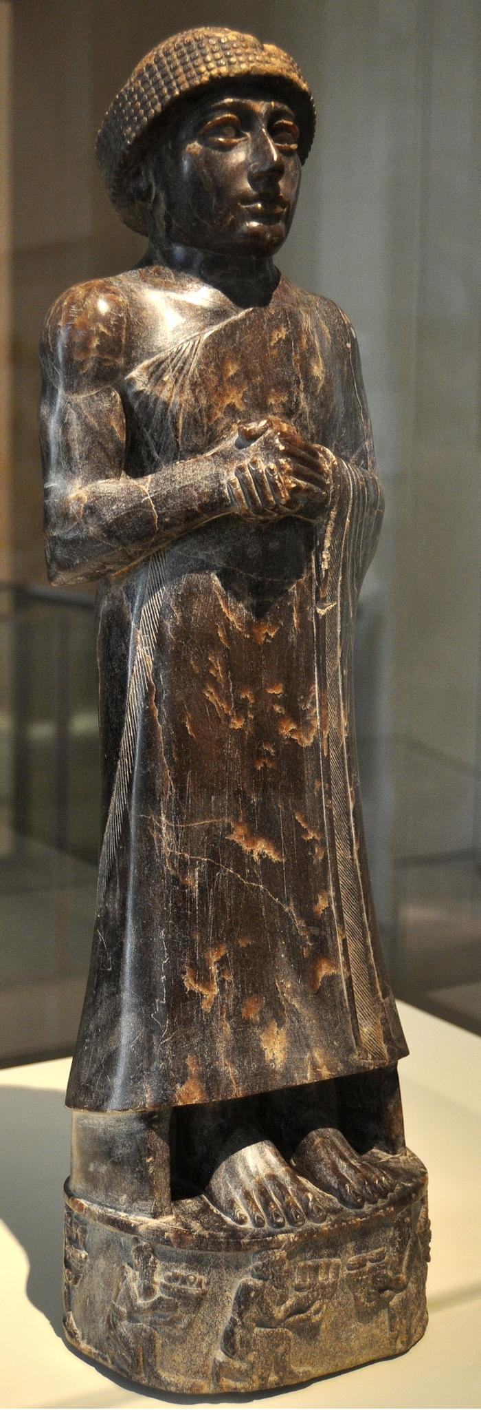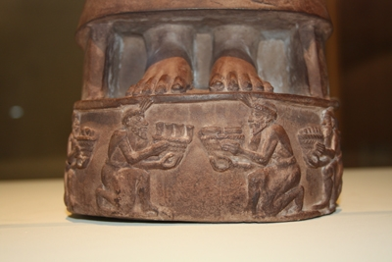

5. What is the significance of Jesus’ reign? How did He achieve such a position? What does it mean to me as a citizen in His kingdom?
6. All of these, the N.T. writers address very specifically.

Discussion:

I. The biblical text makes it obvious that God is the one who brings Christ to sit at His right hand.

A. “The LORD says to my Lord (“adonay”).” The LORD will stretch forth Your strong
scepter.”
1. The Hebrew translated “LORD” in the NASB is the word “Yehovah” in Hebrew, the
tetragrammaton, represented by four Hebrew consonants, with no vowels for
pronunciation.

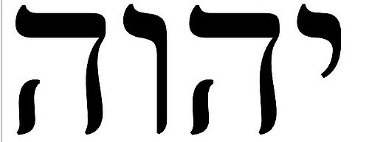
2. It represents the proper name of God, too great to be pronounced.
B. Jesus perplexed the Pharisees by asking, “Whose son is the Christ?” When they said,
“The son of David.” Jesus asked, “Then how does David in the Spirit call him ‘Lord,’”
quoting Psa. 110.
1. Jesus’ acknowledgement of David’s speaking “in the Spirit” validated David as
speaking from God.
2. But how could he, the great king and predecessor, call Christ Lord?
C. God, as the ultimate authority, seats Christ at His right hand.
1. Eph. 1:20 says, “God raised Him from the dead and seated Him at His right hand in
the heavenly places.”
2. To be seated at the right hand is the most exalted and authoritative position. The
only authority greater is God Himself (1 Cor. 15:20-28).

II. Christ achieved this position by sacrificing Himself on the cross.

A. This is the greatest paradox of history that Jesus would be exalted to the right hand of
God by means of humiliation.
B. Numerous N.T. passages call this to our attention.
1. Phil. 2:7-11.
2. Gal. 3:13 says, “Christ redeemed us from the curse of the Law, having become a
curse for us—for it is written, ‘Cursed is everyone who hangs on a tree.’”
3. Heb. 1:3: “When He had made purification for sins, He sat down at the right hand of
the Majesty on high.”
4. Heb. 10:12: “He, having offered one sacrifice for sins for all time, sat down at the
right hand of God.”
5. Heb. 12:2: “For the joy set before Him He endured the cross, despising the shame,
and has sat down at the right hand of the throne of God.”
6. His actions are consistent with what He taught. The avenue to the chief places in
the kingdom is through “drinking the cup” that He was about to drink in giving His life
a ransom for the many (Matt. 20:20ff).

III. The message of the gospel is that He is now reigning.

A. The evangelistic command to go and make disciples is founded on His having been
granted “all authority in heaven and on earth” (Matt. 20:18-20).
B. Peter’s preaching on Pentecost proclaimed the coronation of the king (Acts 2:30-36).
C. Paul and Silas were proclaiming another king, not Caesar, but Jesus (Acts 17:7).

IV. What does all this mean?

A. It means that He has subdued his enemies.
1. 1 Pet. 3:22: “Jesus Christ is at the right hand of God, having gone into heaven,
after angels and authorities and powers had been subjected to Him.”
2. Eph. 1:21-22: He is “far above all rule and authority and power and dominion, and
every name that is named, not only in this age but also in the one to come. He put
all things in subjection under His feet, and gave Him as head over all things to the
church.”
3. The one enemy that remains is death (1 Cor. 15:24-28).
B. It means that He serves as our High Priest interceding for us.
1. Heb. 8:1ff: We have such a high priest, who has taken His seat at the right hand of
the throne of the Majesty in the heavens, a minister of the true tabernacle, which
the Lord pitched and not man.” He has offered Himself as a sacrifice for us.
2. Rom. 8:34: “Who is the one who condemns? Christ Jesus is He who died, yes,
rather who was raised, who is at the right hand of God, who intercedes for us.”
C. It means that though we may die for Him He is concerned about us.
1. Most passages refer to Jesus seated at the right hand of God.
2. One passage refers to Him standing at the right hand of God.
3. Stephen’s accusers were cut to the quick by his words and they were grinding their
teeth at him. He saw “the heavens opened up and the Son of Man standing at the
right hand of God,” this immediately before they stoned him to death (Acts 7:56).
D. The challenge to us is to present our lives to Him in self-sacrifice (Col. 3:1ff).
E. The result is that we will reign with Him. Rev. 3:21: “He who overcomes, I will grant
to him to sit down with Me on My throne, as I also overcame and sat down with My
Father on His throne.” “Our citizenship is in heaven, from which we eagerly wait
for a Savior, the Lord Jesus Christ; who will transform the body of our humble state
into conformity with the body of His glory, by the exertion of the power that He has
even to subject all things to Himself” (Phil. 3:20-21).
F. For those who are His enemies it means they will be crushed under His feet.

Conclusion:

1. Are you His enemy?
2. Are you a citizen in His kingdom?
3. Are you waiting for the coming of your King and the defeat of death?

