Not As the Word of Men
1 Thess. 2:13

Introduction:

1. Will Rogers was born Nov. 4, 1879 in Oologah, OK. Known for his uncanny wit, on one occasion he said, “Live in such a way that you would not be ashamed to sell your parrot to the town gossip.”
2. Words are powerful tools whether through the voice of a parrot, the town gossip, or God Himself.
3. The Thessalonian believers certainly saw a marked difference between the words of men and the word of God.
4. In 1 Thess. 2:13 Paul said, “We thank God that when you received the word of God, which you heard from us, you accepted it not as the word of men, but for what it really is, the word of God, which performs its work in you.”
5. It is a magnificent thing for God to communicate with men. But how do we distinguish the word of God from the word of men? Once we do, how should we respond to the word of God?

Discussion:

I. There are various theories about God communicating with men.

A. Some claim that God does not exist.
1. For these, how God communicates is a moot question. If He does not
exist there is no communication from God.
2. All communication then is merely the word of men. No
communication therefore is any more authoritative than any other.
3. This was certainly not the view held by Paul and the Thessalonians.
B. Others believe in various gods and sources of communication.
1. This is acknowledged in Deut. 18:9ff where Moses speaks of those
who use divination, who practice witchcraft, interpret omens, are
sorcerers, cast spells, are mediums, are spiritists and those who call
up the dead. He was describing the religion associated with the
Canaanites.
2. Examples of “divination” from ancient Babylonia. From the Louvre in
Paris.
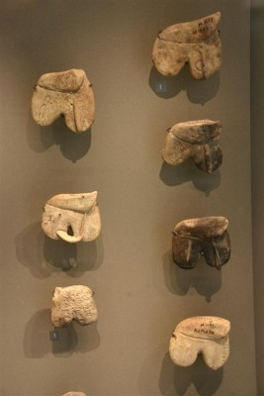 “The king of Babylon stands at the parting of the
way . . .to use divination; he shakes the arrows,
he consults the household idols, he looks at the liver” (Ezek. 21:21).

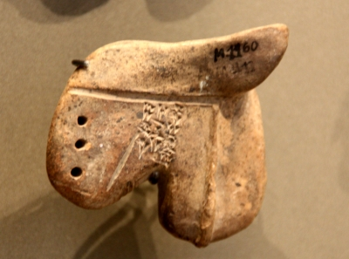

3. This was part of the idolatry of ancient peoples, but God’s people from
ancient times were forbidden to listen to such sources. “Could people
really learn the future by such means?” NO! But even if they could, God
prohibited it! The reason God prohibited it is because He is the only God,
the only one able to foretell the future and these idolaters were only
speaking the words of men deceiving their followers.

C. The first century world at Thessalonica was characterized by polytheism.
A variety of gods were acknowledged. Some were Egyptian in origin:
Isis, Osiris, Serapis, Anubis, and others. The Cabirus cult borrowed from
Samathrace is said by some to have been prominent. And then there
was the worship of the Roman Emperior, also known as Imperial
worship. Along with all these there were the gods worshiped all over the
Greco-Roman Empire: Aphrodite, Demeter, Zeus, Artemis, Apollo, and
others.
1. From such the Thessalonians turned to serve the true and living God.
2. The contrast then is between the true and living God and all others.
3. Indeed, this is what Paul was in the habit of preaching. At Ephesus
Paul said, “gods made with hands are no gods at all” (Acts 19:26).
D. In our culture all such perceptions are usually cast aside. Nevertheless,
there are other theories that are prominent.
1. Catholicism says when the Pope speaks “ex cathedra” he
communicates God’s message.
2. Jehovah’s Witnesses have their “Latter Day” revelation and Morman’s
have their Book of Morman that they claim is “another revelation of
Jesus Christ.”
3. Some believe in what they call “Holy Spirit illumination.” This involves
the idea that we cannot understand the Bible and the Holy Spirit
illuminates the message. Trouble is, different groups all claiming Holy
Spirit illumination come up with different and contradicting messages.
4. Still others believe that God communicates with them personally.
E. The Thessalonians turned from such things to receive the word of God.
1. They were responsible to distinguish the word of God from the word
of man.
2. If we are determined to serve the God of heaven we must do the
same.

II. How can we determine the word of God?

A. Deut. 18:15-22 indicates that God generally communicates through
prophets.
1. There are occasions in the Scripture where God communicated
directly to individuals, but these are exceptions.
2. The general rule is that God communicates through spokespersons.
B. Heb. 1:1-2a; 2;1-4 summarizes how God communicates.
1. In the prophets.
2. Through His Son.
3. Confirmed to us by those who heard. God validating their message with
signs, wonders, miracles and gifts of the Holy Spirit.
C. 1 Jn. 1:1-5 reiterates the same.
D. 2 Pet. 1:16-21 makes the claim that what Jesus’ apostles spoke they spoke
from God.
E. The Thessalonians had heard the word of God from Paul.
1. He claimed that what he spoke came from God (1 Cor. 2:6-13).
2. He referred to the sacred writings in 2 Tim. 3:15ff and spoke of
Scripture being inspired by God.
F. Do you believe the Bible is the word of God? One thing about the Bible, it
simply does not tolerate the acceptance of multiple sources of
communication.
1. Either God is the source, or men (Matt. 21:23-27).
2. Who do people say? vs. My Father who is in heaven (Matt. 16:13ff).

III. If we believe the Bible is the word of God how shall we then respond?

A. We must pay close attention (Heb. 2:1-3).
1. There is penalty for failure.
2. We cannot afford to neglect it.
B. When the Thessalonians received the word of God . . . (1 Thess. 2:13)
1. They turned to God from idols.
2. That word performed a work in them.
3. They became imitators of the churches of God in Judea enduring
persecution as they sounded forth the word of the Lord (1 Thess.
2:14; 1:8).
4. They disciplined their lives to please God (1 Thess. 4:1ff; 5:14ff).
5. They waited on the return of the Lord (1 Thess. 1:10; 5:13ff).

Conclusion:

1. Would you receive the word of God today?
2. Allow it to do its work in you?
3. Turn from the words of men and be transformed by the word of God.

