Worship (1)
Jn. 4:20-26

Introduction:

- Worship. We all know what it is, or do we? “But we have been doing it for years,” someone observes. “What does God think of what we are doing?” “How can we know what God thinks of what we are doing?”
- The answers can only be found in the text of Scripture, God’s authoritative word of truth.
- And so, to the authoritative word of God we must go to investigate worship. True worship . . . what it is . . . how it is to be done . . . and what is pleasing to God cannot be defined based on our thinking else it be transformed into self-worship rather than God worship.
- We must ask, “Who is this God that we worship?” “Who are we, His worshipers?” “What does worship even mean?” These are some of the questions we want to address in this series of lessons.
- The Samaritan woman had questions about worship. She thought a prophet could answer them. Jesus said that her worship was uninformed. He said, “You worship what you do not know.” He indicated that Jews had information, but that that information was being enlarged. She said, “The Messiah will declare all things to us.” Jesus said, “I who speak to you am He.”
- Immediately we learn some important things. 1) Worship without knowledge is insufficient. 2) True worship is revealed. 3) There is a connection between revealed Jewish worship and revealed Messianic worship. 4) Yet, true worship experienced transitional changes with the coming of the Messiah.
- There are a variety of terms that are used in Scripture that connote worship. In this lesson we will consider some of them. In later lessons we may consider others as we try to flesh out and expand our understanding of what it means to worship God.

Discussion:

- There are three major Hebrew words translated “worship” in the NASB.

- “Shachah” (7812 NASB Exhaustive Concordance).
- From a primary root meaning “to bow down.”
- It is variously translated in the NASB as “bow down,” “homage,” “prostrate,” and “worship.”
- It is used in Gen. 22:5 when Abraham spoke to his young men before he offered Isaac. He said, “I and the lad will go over there; and we will worship and return to you.”
- It is used throughout the books of Exodus and Deuteronomy in the prohibitions of worshiping “other gods.”
- Ex. 20:5: “You shall not worship them or serve them.”
- Ex. 23:24: “You shall not worship their (the Amorites, the Hittites, the Perizzites, the Canaanites and Jebusites) gods, nor serve them.”
- In Deut. 30:15-18 Moses contrasted loving the Lord with worshiping other gods. “I have set before you today life and prosperity, and death and adversity; in that I command you today to love the Lord your God, to walk in His ways and to keep His commandments and His statutes and His judgments, that you may live and multiply, and that the Lord your God may bless you in the land where you are entering to possess it. But if your heart turns away and you will not obey but are drawn away and worship other gods and serve them, I declare to you today that you shall surely perish.”
- The idea of “bowing down before” carries the significance of humbling oneself to be under the control of another. 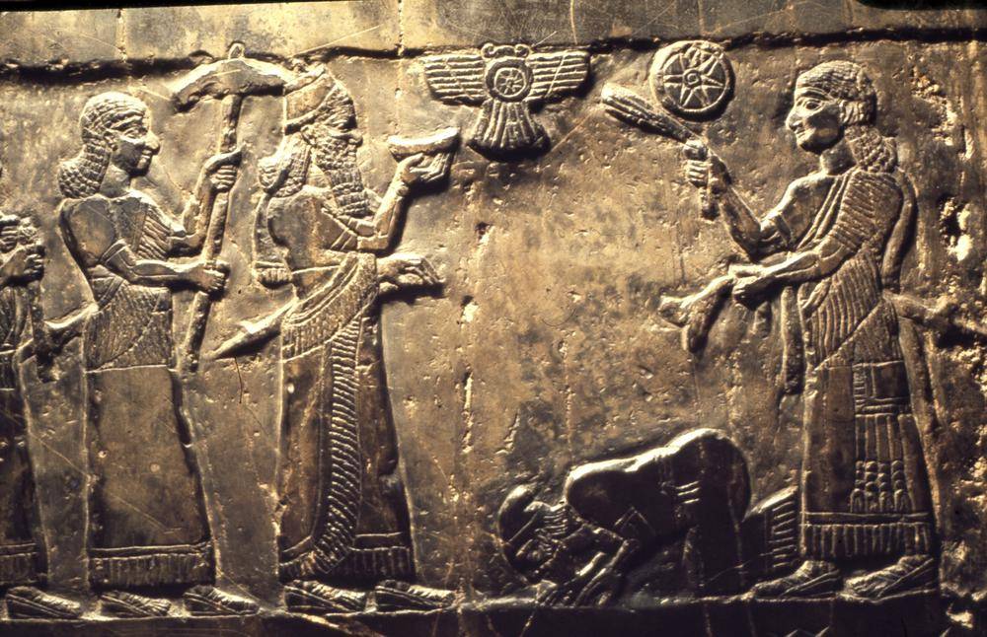
The Black Obelisk showing the Israelite King Jehu bowing before the Neo-Assyrian king Shalmaneser III
- “Abad” (5647).
- From a primary root meaning “to serve” or “to work.”
- It is the word used in Ex. 20:5 along with “shachah” (to bow down).
- It is the word used by God when he said to Pharaoh, “Let My people go, that they may serve Me (Ex. 8:1, 20; 9:1, 13; 10:3, 7, 8).
- “Segid” (5457).
- “To prostrate oneself,” “to do homage,” “worship.”
- This is the word that is used in Daniel 3 when the Babylonian king Nebuchadnezzar called on Shadrach, Meshack and Abed-nego to worship the golden image that he had set up.
- In Dan. 3:18 they said, “We are not going to serve your gods or worship the golden image that you have set up.”
- There are other words that are translated with such concepts as “fall down before” and “to serve” but these give us a clear idea of what it means “to worship” in the O.T.
- Deut. 30:15-18 summarizes it as “loving the Lord,” “walking in His ways,” and “keeping His statutes.” The result is life and prosperity. Failing to obey Him but submitting to other gods results in perishing.
- In the N.T. language the same ideas come across.

- “Proskuneō” (4352).
- Means “to do reverence,” “to bow down,” “to prostrate oneself” as in kissing the earth.
- “Kuneō” means “to kiss.”
- It is the word used in Jn. 4:20-24 with the Samaritan woman.
- It is the word used by the magi who came to worship the baby Jesus (Matt. 2:2).
- It is the word used by Satan in the temptation of Jesus . . . “If you will fall down and worship me . . .” (Matt. 4:9).
- And the word used by Jesus. “You shall worship the Lord your God” (Matt. 4:10 quoting Deut. 6:13 translating the Hebrew term “yare” 3372a often translated “fear” in the NASB. Not terror, but reverence or respect as a result of the awesomeness of God.)
- “Sébō” (4576).
- This word is translated “devout,” “God-fearing,” “worship,” and “worshiper” in the NASB.
- “In vain do they worship Me, teaching as doctrines the precepts of men” (Matt. 15:9; Mk. 7:7; quotation from Isa. 29:13; “reverence,” 3372a, often translated with the word “fear”).
- Two things from this text: the doctrines of men result in vain worship; and heart worship has been required from O.T. times.
- “Sebasma” (4574).
- Denotes an object of worship.
- It is used in Acts 17:23 of the idols of Athens.
- “Eusebeō (2151).
- Means to show piety toward.
- Also used in Acts 17:23 when Paul says, “What you worship in ignorance, this I proclaim to you.”
- This makes “Sebasma” and “eusebeō” synonymous by Paul.
- Worship based in ignorance or on the doctrines of men is insufficient. This undergirds the presupposition of this series, namely, that only worship that is revealed is satisfactory.
- “Latreia” (2999), “latreuō,” (3000).
- These two terms represent the idea of service.
- The first is used in Rom. 12:1 where Paul calls on brethren to present their bodies a living and holy sacrifice, “which is your spiritual service of worship.”
- The second is used in Phil. 3:3 where Paul speaks of the true circumcision, who worship in the Spirit of God and glory in Christ Jesus and put no confidence in the flesh.” This is an interesting text that references worshiping in the Spirit of God which stands in contrast to the flesh associated with O.T. circumcision, genealogy, zeal and righteousness.
- “Thrēskeia” (2356).
- Used in Col. 2:18 where Paul speaks of the worship of the angels.
- Sometimes translated “religion” in NASB as in James 1:27: “Pure and undefiled religion is to visit the fatherless and widows in their affliction.”
- “Gonupeteō” (1120).
- Not translated “worship” in NASB.
- It is formed from two words. The word for “knee” and the word for “fall.” Literally it means to fall on one’s knees.
- It is used in Lk. 22:41 when Jesus was in the Garden of Gethsemane immediately prior to His crucifixion. “He kneeled down and prayed.”
- Such bending of the knee denotes humility, self-abasement, submission, and respect.
- Associated with the Latin word “genuflectere,” from which we get our word “genuflect.”

- What have we learned about worship?

- Worship that is acceptable to God is revealed from Him.
- Worship in ignorance is not acceptable.
- Worship that originates with men is not acceptable.
- Worship involves humility and submission as suggested by the concepts of “bowing down,” and “kissing the earth.”
- Worship involves service, not as though God needed anything, but a submission to the accomplishment of His will considering His awesomeness.
- There is a “fear” associated with the worship of God, not out of terror, or condemnation although the same word is used of terror, but this fear comes as a result of His awesomeness. Great care must be given to our relationship to Him.

Conclusion:

- Worship is all about humbling ourselves before the mighty God.
- Phyllis and I had a conversation the other day about someone who said they did not believe baptism was necessary. I remarked that I did not believe that people really have a problem with baptism. I think they have a problem with humility. I think they have a problem submitting themselves to God.
- People get wet all the time. They really don’t have a serious problem with that.
- But baptism represents submission. It means humiliation before God and some people are just not willing to go there.
- They argue that they don’t believe baptism is necessary. The problem is not baptism. The problem is giving ourselves up to Him. It’s a faith issue. It’s a worship issue. If you can’t give yourself up in baptism how can you be a worshiper of God?

