Worship 5
The Biblical Perspective on Idolatry 1
Jer. 10:1-10

Introduction:

1. “The way of the nations,” “the custom of the peoples,” “delusion,” “the work of men’s hands,” “like a scarecrow in a cucumber field,” these are the Lord’s descriptions of idols in Jeremiah.
2. “Vain idols,” “empty vanities” (Psa. 31:6), “abominations” (Isa. 66:3) are descriptions given by David and Isaiah.
3. Daniel I Block says that Ezekiel’s favorite word for idols is “gillûlim.” He translates it “dung pellets” and says it is probably derived from the peanut-like shape of sheep excrement” (For the Glory…, p. 32 fn. 9) Cf. Ezek. 6:4.
4. Paul diminishes idols saying, “There is no such thing as an idol,” and refers to them as “so-called gods” (1 Cor. 8:4-5) and “no gods at all” (Gal. 4:8).
5. The gods, images are supposed to represent, do not exist. They are like scarecrows, effigies, vanities, and even dug pellets. They are nothings.
6. But the Bible’s description does not end here. What does it say about those who worship idols? What characterizes the worship of idols? What are the results of worshiping idols? These are the kind of questions we want to address in this lesson and in part 2 of The Biblical Perspective on Idols.

Discussion:

I. One of the earliest mention of idols in Scripture is the account of Rachael’s taking of her father, Laban’s household idols (Gen. 31:22ff).

A. These were idols that could be put in a camel’s saddle (34).
B. They could be sat on (34). She sat on her gods!!
C. This is certainly not the earliest history of idol worship. Abraham’s fathers were idol
worshipers in Ur before God called Abraham (Josh. 24:2).

II. Idol worship characterized the Egyptians when the Israelites were enslaved. Such idol worship was perpetuated throughout Israel’s history.

A. The ten plagues were designed to demonstrate God’s power over their idols. Note their
polytheistic perception. This contrasts with God’s singular presentation of Himself.
B. The golden calf incident probably stemmed from the idolatry of Egypt (Ex. 32). Note Ezek.
20:7-8.
1. Daniel I Block (For the Glory…, pp. 31, 32) notes that several ancient texts from Assyria
explain how a physical object was thought to become a god. There are similarities
between this process and the description given in Ex. 32.
a. Artisans were carefully chosen and ritually consecrated, preparing them to enter
the temple workshop, where statutes of the gods and other sacred objects were
made and animated.
b. The artisans crafted the image, using the materials available (wood, stone, clay,
metal, bone, etc.).
c. Through special rites of divination, a propitious day in a favorable month was
chosen for the “birth of the god.”
d. By special incantations and a ritual referred to as “the opening of the mouth” or
“washing of the mouth,” the god was “born”; that is a physical object was
transformed into a living representative of the deity, capable of smelling incense,
drinking water, eating food, hearing prayers, and speaking words of reassurance or
hope.
e. Special rituals were performed to disassociate images from the human hands that
made them, reinforcing the conviction that they were indeed divine creations. The
artisans denied under oath that they had made the images, affirmed that they had
been made by the craft deities, and had their hands cut off. The tools used to
make the image were returned to the craft god by wrapping them in the carcass of
a sheep and throwing them into the river.
f. The gods were installed in the “holy of holies” of their temples, constructed as their
official residences.
g. To ensure the gods’ favorable disposition toward worshipers, priests were
appointed to care for the deities’ material needs: animal and vegetarian sacrifices
to satisfy their appetites and incense as a soothing aroma. The cult statutes were
regularly bathed, dressed in fine garments, put to bed, and treated to festivities
and musical entertainment.
2. Moses burned the calf Aaron had made, ground it to powder, and scattered it over the
surface of the water and made Israel drink it. The idol that they had made was
powerless. It went through the digestive system. How common and mundane!!!
3. This incident is cited repeatedly in Scripture (ex. Deut. 9:16ff; Acts 7:41; 1 Cor. 10:7) as an
act repudiating God. Stephen condemned those who rejected Jesus as “stiff necked and
uncircumcised in heart and ears and always resisting the Holy Spirit.” He said, “You are
doing just as your fathers did.”
C. The images of Baal and Asherah were cut down by Gideon (Judges 6:25-32). Joash,
Gideon’s father said to those who objected, “Will you contend for Baal? If he is a god, let
him contend for himself.”
D. The images of Dagon (the Philistine god) fell before the ark of God (1 Sam. 5:1-5).
E. Baal and the prophets of Baal were impotent before God and Elijah (1 Kings 18:20-39).
1. They called on Baal from morning until noon. Elijah mocked them in ways reflecting
their own perceptions of the limitations of their god: difficulty hearing, on a journey,
asleep.
2. They cut themselves with lances, I suppose trying to get Baal’s attention.
3. They raved until time for the evening sacrifice.
4. No answer, no voice, no one paid attention.
5. Elijah’s prayer, of course, was answered in a timely way.

A modern depiction located on Mt. Carmel of Elijah’s slaying of the prophets of Baal.
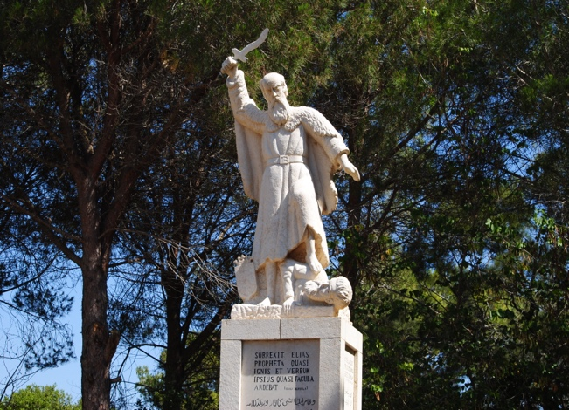
f. The summary of Psa. 115:4-8.

III. The objection of some today: “I would be a believer if God acted in this way today.”

A. I would argue that in some ways He does.
1. He causes the sun to rise and he causes it to rain (Matt. 5:45).
2. He gave His Son (Acts 2:22-23).
3. He raised Him from the dead (Acts 2:24).
4. God has communicated. If men will not hear what God has communicated, they will
not be persuaded even if someone rises from the dead (Lk. 16:29-31).
5. Those who seek for a sign (Matt. 16:4; Lk. 11:29ff).
B. The idols of men produce no miracles.
1. The God of heaven has and will (Jn. 5:28-29).
2. The idols of men have not intervened in the history of mankind.
3. The God of the Bible has not only intervened He has intervened with His graciousness
(2 Pet. 3:9). He is calling men to repentance. He will judge the world through the
One He has appointed having furnished proof by raising Him from the dead (Acts
17:30-31).

Conclusion:

1. Each of us faces a choice.
2. Either we acknowledge the God of the Bible or we do not.
3. Rom. 1:18ff speaks to this issue. Humanism, elevating humans to the level of deity, is just another form of idolatry.
4. Idolatry is not always about worshiping an image. Eph. 5:5; Col. 3:5 speaks of pursing the things of the world as idolatry.

