The Judgment of the Great Harlot
Rev. 17

Introduction:

1. In the previous lesson we observed a sign in heaven, seven angels with seven bowls of the wrath of God.
2. Each of these was poured out on the earth as His judgment was brought to bear on those on the earth who refused to repent.
3. The victorious, sang a song of praise to God in honor of His righteous judgment.
4. As chapter 17 opens a new scene appears. One of the seven angels says to John, “Come here, I will show you the judgment of the great harlot who sits on many waters.”
5. 17:5 identifies her as “Babylon the Great.” 16:19 had introduced Babylon as the great city being remembered by God. Now she is identified as a great harlot, with whom the kings of the earth commit acts of immorality. She is riding on a beast.
6. Who is Babylon the harlot? Who is the beast upon which she rides? What do these images represent? What do they mean for us today?

Discussion:

I. The harlot is identified as “Babylon the Great” (cf. 14:8; 16:19), which to John’s readers would have symbolized Rome.

A. The harlot imagery is from the Old Testament.
1. Nahum 3:1-4 portrays Nineveh as a harlot under the condemnation of God.
2. In Isa. 23:15-17 the city of Tyre is portrayed as a harlot under the condemnation of
God.
3. In Isa. 47:5-15 Babylon is portrayed as a daughter exposed under the condemnation
of God for having mistreated God’s people.
4. Isa. 1:21 and Jer. 2:20 portrays Jerusalem as a harlot unfaithful to the Lord.
5. Also Jer. 3; Ezek. 16; Hosea.
B. In the first century, Rome was emblematic of the world’s seduction to materialism and
sensual pleasures.
1. Here the harlot is clothed in purple and scarlet, adorned with gold and precious
stones and pearls. She is made to look attractive.
2. The golden cup in her hand is full of abominations and the unclean things of her
immorality.
3. Certainly Rome was characterized by physical immorality, but the reference here is to
her worldliness including wealth, idolatry, emperor worship and other idolatrous
practices.
4. James warns his Christian readers of the pull to commit adultery by forsaking the
Lord for such things (4:1-10).
C. This woman was drunk with the blood of the saints and with the blood of those who
testify about Jesus (v. 6).
D. John says he wondered greatly about the woman and the beast that carried her. The
angel said he would explain to him the mystery. Verses 8ff then continues that
explanation.

II. The angel’s explanation of the mystery of the woman and the beast (8-13).

A. Who is this beast who was, and is not, and is about to come up out of the abyss and go
to destruction?
1. Those dwelling on the earth wondered.
2. They are distinguished from those whose names are written in the book of life.
3. So those who are wondering are the unfaithful.
B. The angel reveals
1. The seven heads of the beast are seven mountains on which the woman sits.
This helps us identify the woman with Rome.
2. Rome was known to sit on seven hills.

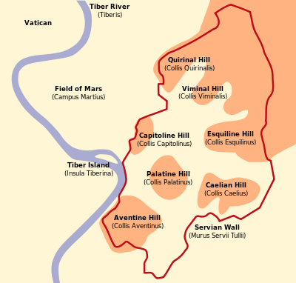

3. There are seven kings; five are fallen, one is, the other has not yet come.
Attempts have been made to identify these with various kings of the Roman
Empire.
4. The beast is an eighth king. Suggests that it is one of the Roman Emperors.
Which one is not clear, but his end is destruction.
5. The ten horns are ten kings who have not yet received a kingdom. They are allied
with the beast and give their power and authority to the beast.
6. Although many have tried to identify who these kings are, their identifications are
best are based on indefinite reconstructions.
7. It is obvious whoever they represent they are associated with those who oppose
God and are the allies of the beast, one of the Roman Emperors.
C. The lamb will overcome them (17:14).
1. He is Lord of lords and King of kings.
2. Those who are with Him, the called and chosen and faithful will overcome because
of Him.

III. Further explanation by the angel (17:15-18).

A. The waters where the harlot (Rome) sits, are peoples and multitudes and nations and
tongues.
B. The ten horns and the beast (kings) hate the harlot (Rome) and will make her desolate
and destroy her.
C. You might well recall that Dan. 2:24ff described the fourth great empire (Rome) as
mixed. Rome had a difficult time bringing the kingdoms she conquered into a cohesive
whole. Dan. 2 describes it as part of iron and part of clay and they would not cleave to
one another.
D. God used these as they turned against Rome.
E. The last statement adds evidence that Rome is the consideration when it says, “The
woman is the great city, which reigns over the kings of the earth.”

Conclusion:

1. For the faithful of the first century the message was, “Vindication. Judgment is coming upon the enemies of God.”
2. Indeed a spiritual war is on. It involves rulers and powers, “world forces of this darkness” (Eph. 6:12) under the influence of Satan.
3. They are waging war against the Lamb and those who are His, but He is victorious as Lord of lords and King of kings.
4. Today we should be comforted that God is in control. Though the rulers and the political machinery of our day give themselves over to the influence of Satan, still we will be victorious by means of the power of the Lamb of God.

