Spiritual Perfection
Phil. 3:8-12

Introduction:

1. I have been asked, “How can I achieve true spiritual perfection?”
2. In the passage we have just read Paul speaks of becoming perfect.
3. But acknowledges that, even he, has not reached it, but he presses on.
4. Spiritual perfection: What is it and how do I get there from here?

Discussion:

I. Initial observations.

A. Christ is the example of true spiritual perfection.
1. It might be said that this sets a goal so high that we can never achieve it.
2. On the other hand, we realize that it could be said that we are made spiritually perfect
through the forgiveness provided by Christ’s blood.
B. Thus there are at least two senses in which we may speak of spiritual perfection.
1. We can talk about moral perfection and the discipline necessary to bring ourselves
into conformity with the will of God.
2. Or we can talk about spiritual perfection as something given us by the power of God.
3. Paul seems to address both ideas in Phil. 3:3ff.
a. He speaks of putting confidence in the flesh and in his performance of the law (3-
9).
1) It is not association with Israel that makes one righteous.
2) It is not a righteousness derived from the law (or the keeping of the rules). It
is too late for that for we have all sinned and fall short of the glory of God
(Rom. 3:23).
b. He contrasts this with “righteousness that comes from God on the basis of faith”
(9).
c. If we look at spiritual perfection as something that we must achieve on our own
power—it is impossible. But if spiritual perfection is something achieved by the
power of God then even what is “impossible with men is possible with God” (Lk.
18:27).
4. Some struggling with these concepts have distinguished between justification and
sanctification. They see justification as something occurring at a particular point in
time and sanctification as an on-going process.
a. The charts below represents this distinction.

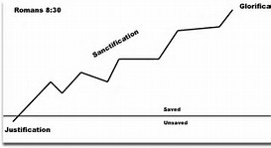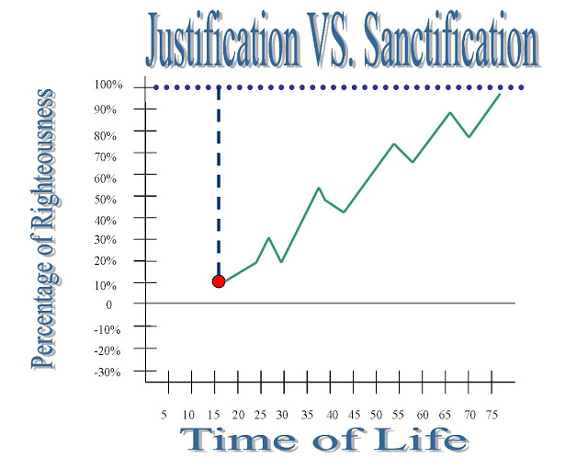
b. The idea is that at the time of salvation an individual is 100% justified and then as
they proceed through life they are constantly growing and working to improve
themselves.
c. While such a distinction between justification and sanctification is not clear in
Scripture (cf. 1 Cor. 6:11) Scripture does recognize the difference between being
granted perfect sinlessness by God through forgiveness and the on-going
process of “putting to death the deeds of the body” (Rom. 8:13; Col. 3:5).
5. Although we are active in this on-going process, even here, we are dependent
upon the Lord for “His strength and His might” for “our struggle is not against mere
flesh and blood powers but against the world forces of this darkness, against the
spiritual forces of wickedness” (Eph. 6:10-12).
6. Two senses of spiritual perfection.
a. Righteousness by faith. That is spiritual perfection by forgiveness.
b. On-going process of “putting to death the deeds of the body.” 2 Cor. 7:1 says,
“Let us cleanse ourselves from all defilement of flesh and spirit, perfecting
holiness in the fear of God.” This is in a context calling us out of the world (2
Cor. 6:14-18).
C. There is yet a third sense in which “spiritual perfection” may be considered as
evidenced in Phil. 3:20-21.
1. That state referred to here as when the Lord “will transform the body of our humble
state into conformity with the body of His glory.”
2. It is associated with that spiritual perfection realized after the resurrection.
3. Scripture sees this as the end to which all of God’s purpose is moving. It does not
mean that we are going to be any more forgiven than we already have been. It
does not mean that this is a separate perfection than what we have already
experienced, but it is the culmination of that spiritual perfection begun at the time of
our forgiveness.

Conclusion:

1. In this study we have identified three senses that we may think of spiritual perfection.
a. A spiritual perfection achieved through forgiveness.
b. A spiritual perfection that involves an on-going process of putting to death the deeds of
the body.
c. A spiritual perfection accomplished when the Lord transforms the body of our humble
state into conformity with the body of His glory.
2. None of these are accomplished by our own power, but by the power of God.
a. By the power of God we are forgiven and yet we submit to that power by faith at the time
of our baptism.
b. By the power of God we put to death the deeds of the body recognizing that we are not
struggling against flesh and blood, but against the spiritual forces of wickedness.
c. By the exertion of the power of God death is overcome and glory realized.
3. Where are you in the process?

