Acts
Lesson 22
27:1-28:31

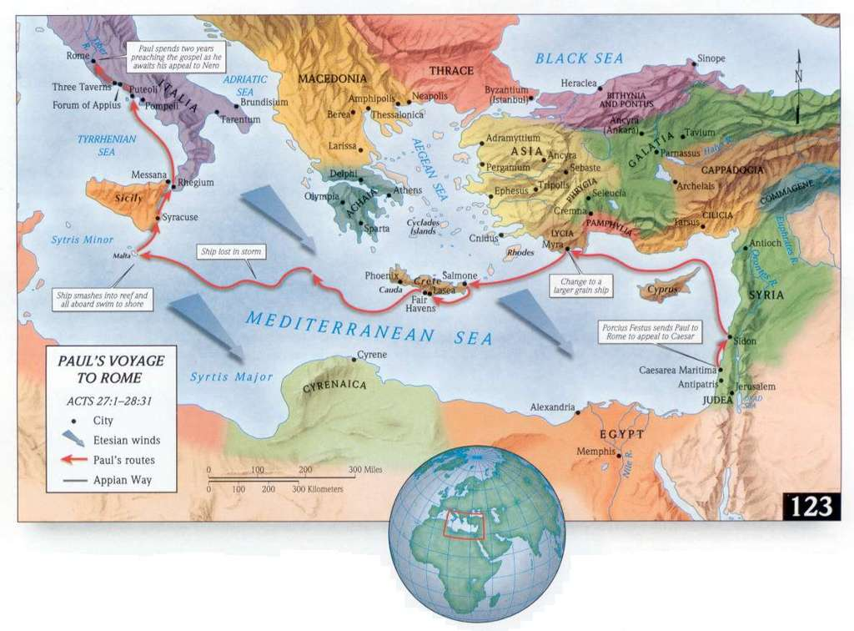
Map available at: http://www.seektheoldpaths.com/Maps/123.jpg

- Paul had a desire and plan to visit Rome for many years
  - Acts 19:21 – While in Ephesus, “Paul resolved in the Spirit to pass through Macedonia and Achaia and go to Jerusalem, saying, ‘After I have been there, I must also see Rome.’”
  - Acts 20:2-3 – Paul spends 3 months in Greece, and this is probably in Corinth. During this time, he wrote the letter to the Romans. In the letter, he discusses his desire and plan to visit them at some point in the future.
    - Romans 1:8-15 – “For I long to see you…I have often intended to come to you…I am eager to preach the gospel to you also who are in Rome.”
    - Romans 15:18-32 – “But now, since I no longer have any room for work in these regions, and since I have longed for many years to come to you, I hope to see you in passing as I go to Spain…At present, however, I am going to Jerusalem bringing aid to the saints.” (15:23-25)
- However, when he arrived in Jerusalem, he was attacked by the Jews and arrested by the Romans. This was definitely not the way that he envisioned this happening, despite the warning of the Holy Spirit as he traveled to Jerusalem. Yet as he sat in a prison one night, the Lord encouraged him by telling him that he would indeed see Rome
  - Acts 23:11 – “The following night the Lord stood by him and said ‘Take courage, for as you have testified to the facts about me in Jerusalem, so you must testify also in Rome.’”
- Despite being declared innocent he is held in Roman custody for political reasons for two years. And when the possibility arises that he might be sent back to Jerusalem for trial, he appeals to Caesar. With that, the wheels are set in motion for him to go to Rome.

27:1-44
- I want to think about Paul’s experience during the storm and ensuing shipwreck. Things haven’t gone exactly according to plan, you’ve ended up in prison unjustly, after being beaten by your brethren. You haven’t exactly had a great couple of years. And now, on your way to Rome, a storm and a major threat to your life.
- Think about the development of these events during the storm
  - v.18 – cargo abandoned
  - v.19 – tackle thrown overboard
  - v.20 – no sun/stars for many days
  - v.21 – without food for a long time
  - v.27 – in this situation for two weeks
- This is a scary and hopeless situation – and this is what Luke communicates in v.20: “all hope of our being saved was at last abandoned”
  - How many times have people in the Bible been in hopeless situations like this? And what usually happens?
    - God often brings men to this point before an intervention – and it usually magnifies his power to deliver from difficult and hopeless situations.
- What does Paul do in this situation?
  - v.22 – Paul encourages the people on the boat: there will be no loss of life, because an angel just appeared to me
    - Note how Paul describes his relationship with God: “the God to whom I belong and whom I worship.” The idea of belonging is comforting in the midst of such a stressful situation.
  - v.33 – Paul urged them to eat and gave thanks to God in the midst of the storm
- When things are bad – when all hope of being saved is abandoned – how do you respond?
  - Do you forget God? Ignore Him in the midst of the storms around you? Get upset when the realities of life don’t meet your hopes and expectations?
  - Or do you keep a positive attitude, let your light shine, and act as an encouragement to those around you?
  - Paul is portrayed here as an ordinary man among men. Along with Luke and Aristarchus, they may have been the only Christians on the boat with a few hundred non-Christians. His faith in God’s promises (v.23-25) provided the basis for his confidence in this situation.
  - God keeps his promises and provides salvation from hopeless situations – this is something that Paul understood and is a lesson we can remind ourselves of during the difficult situations we face in life.

28:1-31
- Upon his arrival in Rome, Paul gets back to his normal routine by connecting with the local Jewish leaders. Surprisingly, they had not heard from the Judean Jews about Paul’s history and activity. The response is typical – some were convinced, but others disbelieved. He re-asserts his resolve to take the gospel message to the Gentiles.
- However, Paul’s situation as the story closes is anything but typical.
  - Allowed to stay by himself from the moment he arrived in Rome, with the soldier who guarded him (v.16)
  - Able to speak to the Jews in Rome without any influence or difficulty from the Asian and Judean Jews (v.21-22)
  - Welcomed all who came to him; able to proclaim the kingdom of God and teach about the Lord Jesus Christ (v.30)
    - with all boldness and without hindrance
  - Was able to write letters – Ephesians, Philippians, Colossians, Philemon
- This is a real lesson on the providence of God. Paul made it Rome…not exactly like he planned, but he eventually made it. And you could argue that it was under better circumstances than he would have ever planned.
  - Perhaps this was on the only way for this happen, and God arranged it perfectly. Imagine the extra layer of protection that he gained through the security of Roman guards.
  - Perhaps this was the way for him to most effectively communicate the gospel to certain people – it is generally believed that he stood in front of the Roman emperor and gave a defense of the gospel.
  - Imagine the great benefit that Christians in all times and places have gained from the letters he wrote – without this imprisonment, perhaps we wouldn’t have these available to us in their current form.
- Are there any apparently adverse circumstances in your life that look different in light of Paul’s experiences?
  - He made it to Rome (his goal) – but as a prisoner (probably not his desired condition)
  - God has a way of modifying our plans in ways that we don’t expect – and bringing out favorable situations for us in ways that we could never envision
- And in a nutshell, that’s the story of Acts – the gospel finds a way…from Jerusalem, to Judea, to the remotest parts of the earth – in the face of great resistance, at times against all odds, God’s way works and always wins

Picture from thebibleproject.com

